**Title:** Familiarization with microcontroller, study of blink test using and implementation of a traffic control system using microcontrollers

# Introduction:

The objectives of this experiment are to-

1. Get familiar with Arduino microcontrollers.
2. Use an Arduino and delay functions to make an LED blink.
3. Implement an LED traffic control system using Arduino.
4. Simulate the microcontroller-based systems using proteus.

**Equipment List:**

* 1. Arduino IDE (2.0.1 or any recent version)
  2. Arduino Microcontroller board
  3. Bread board
  4. LED lights (Red, Green, and Yellow)
  5. Three 200  resistors
  6. Jumper wires

# Circuit diagram:

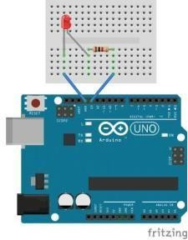

***Fig-1:*** *LED Blink Test using an Arduino Microcontroller Board*

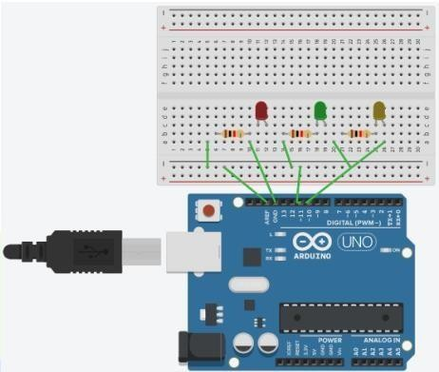

***Fig-2:*** *Traffic Control System using an Arduino Microcontroller Board*

# Code/program:

int led=13; void setup () {

pinMode(led, OUTPUT);

}

void loop () {

digitalWrite (led, HIGH); delay (1000); digitalWrite (led, LOW); delay (1000);

}

**LED Blink**

#define RED_PIN 8

#define YELLOW_PIN 10

#define GREEN_PIN 12 int red_on = 3000;

int red_yellow_on = 1000; int green_on = 3000;

int green_blink = 500; int yellow_on = 1000;

**Traffic Control System**

void setup() { pinMode(RED_PIN, OUTPUT);

pinMode(YELLOW_PIN, OUTPUT); pinMode(GREEN_PIN, OUTPUT);

}

void loop() { digitalWrite(RED_PIN, HIGH); delay(red_on);

digitalWrite(YELLOW_PIN, HIGH); delay(red_yellow_on);

digitalWrite(RED_PIN, LOW); digitalWrite(YELLOW_PIN, LOW); digitalWrite(GREEN_PIN, HIGH); delay(green_on); digitalWrite(GREEN_PIN, LOW);

for(int i = 0; i < 3; i = i+1)

{

delay(green_blink); digitalWrite(GREEN_PIN, HIGH); delay(green_blink); digitalWrite(GREEN_PIN, LOW);

}

digitalWrite(YELLOW_PIN, HIGH); delay(yellow_on); digitalWrite(YELLOW_PIN, LOW);

}

# Hardware Implementation: LED Blink Test

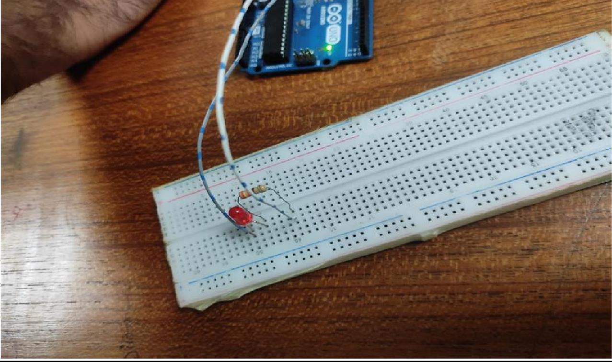

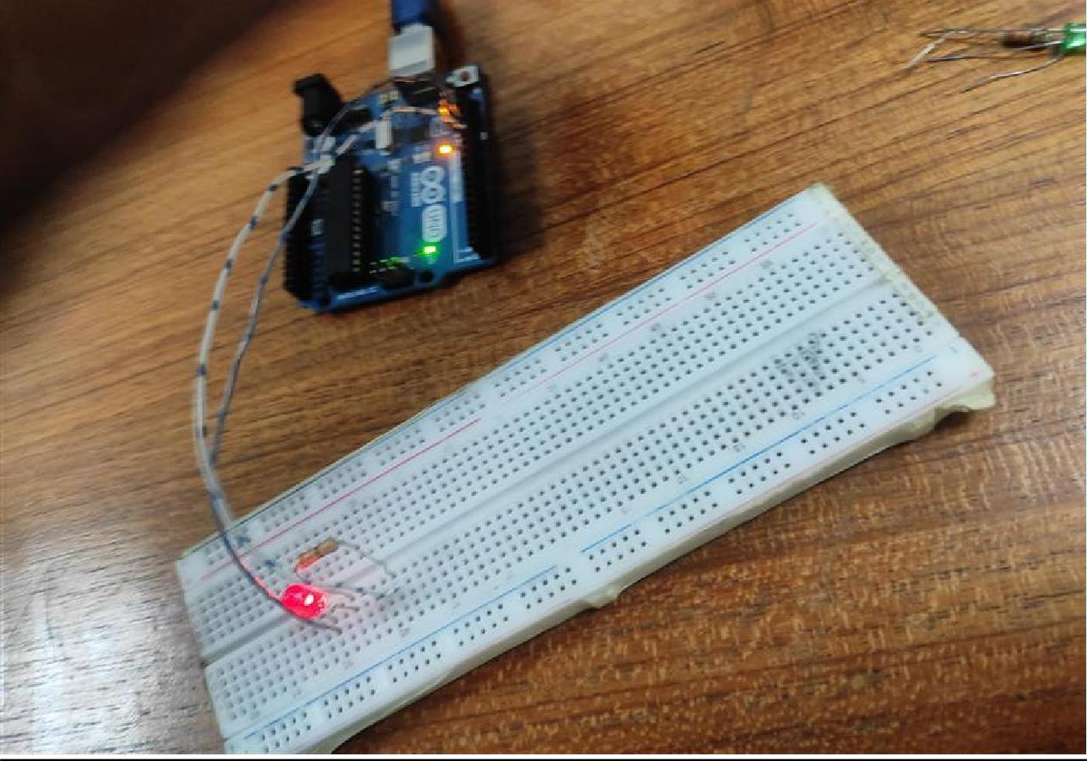

**Traffic Control System**

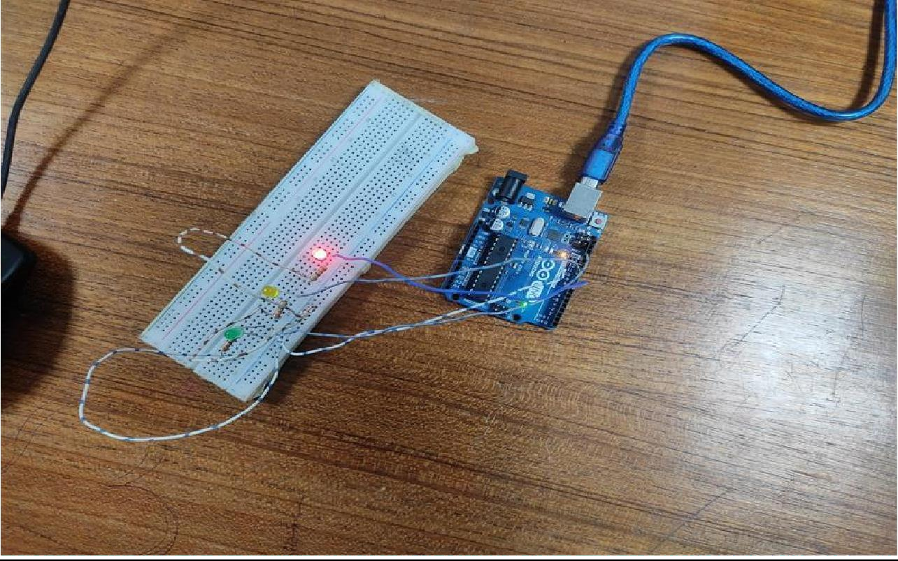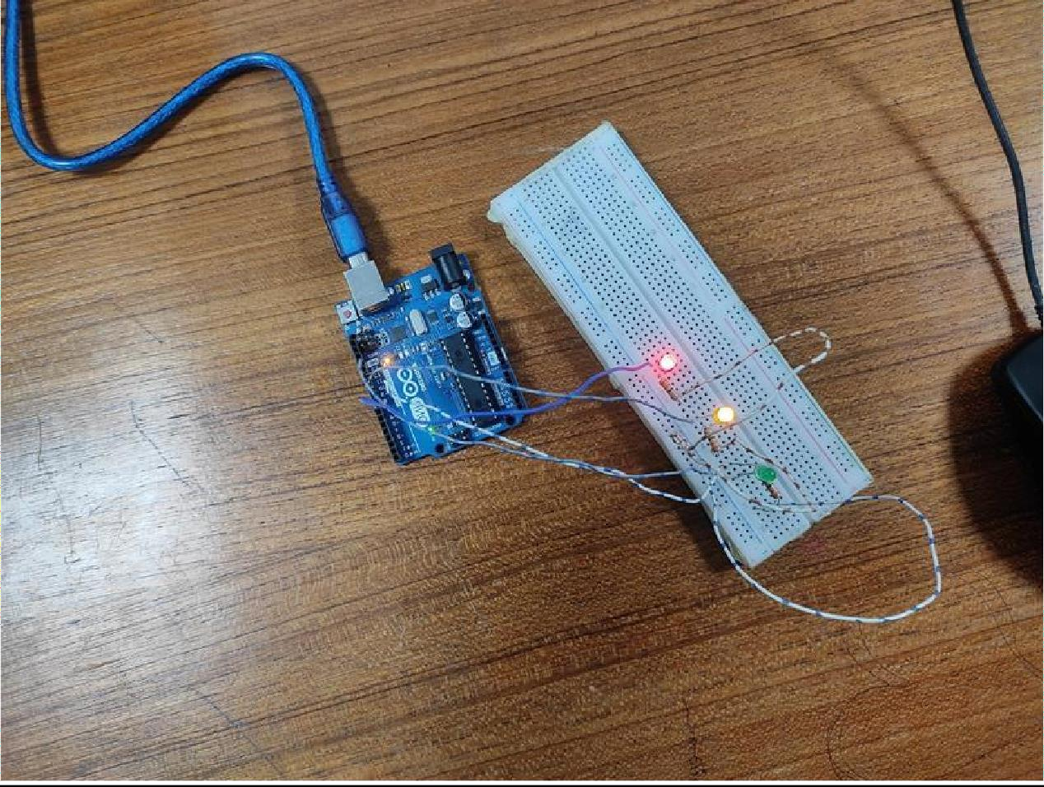

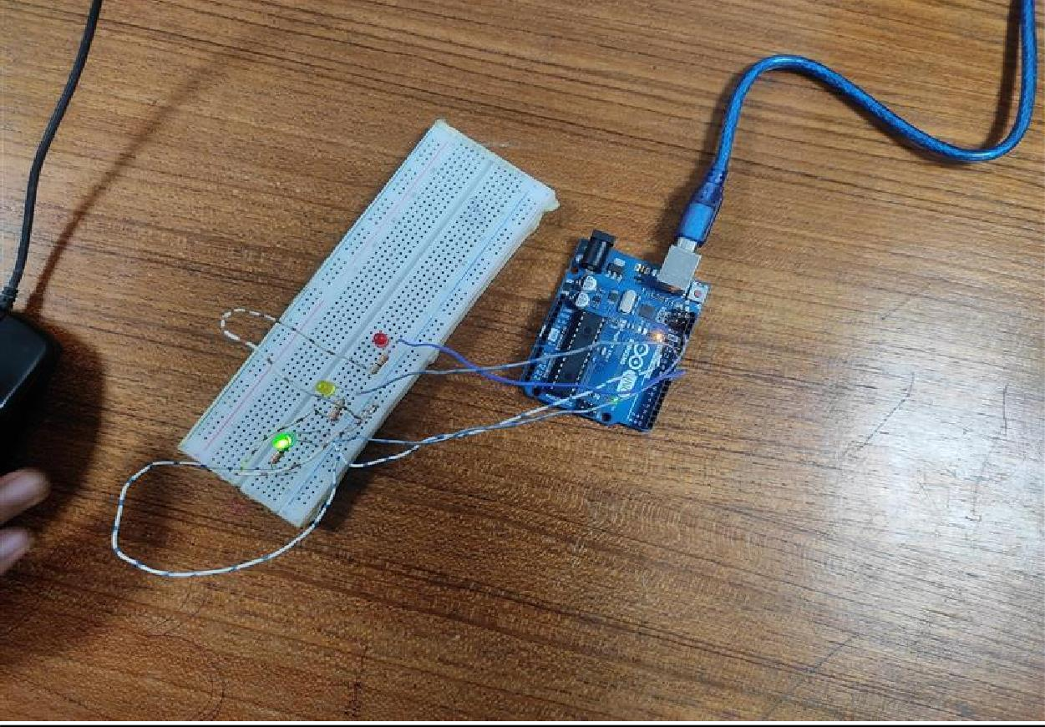

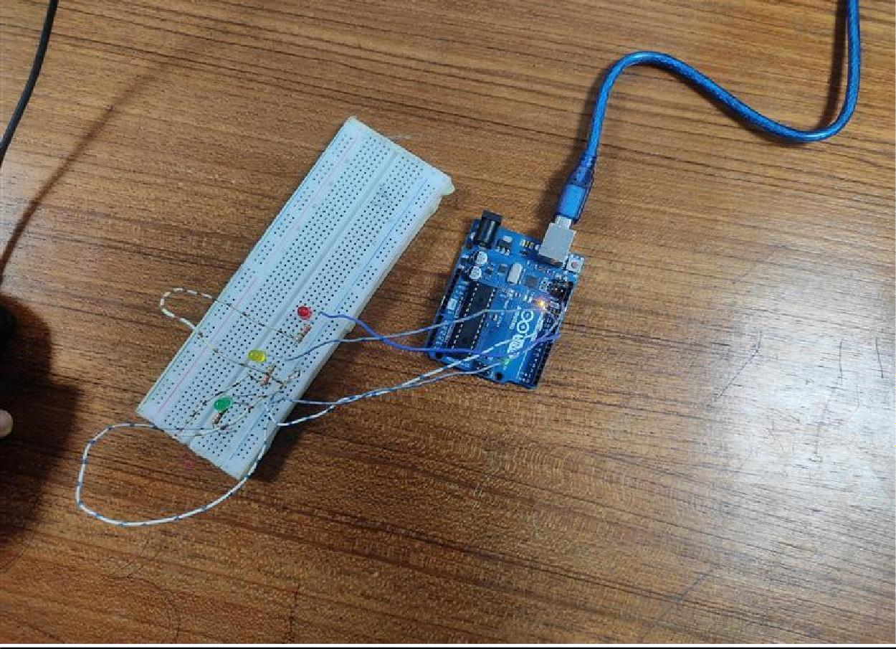

# Simulation:

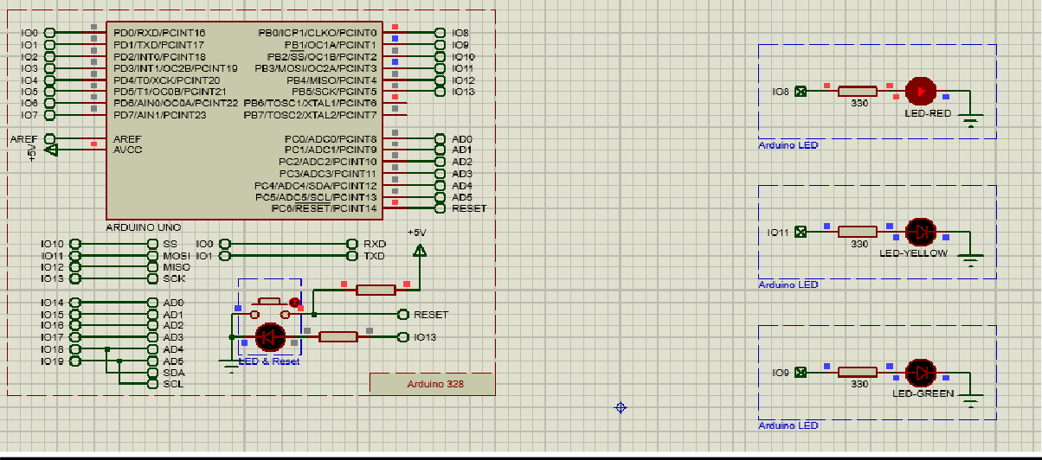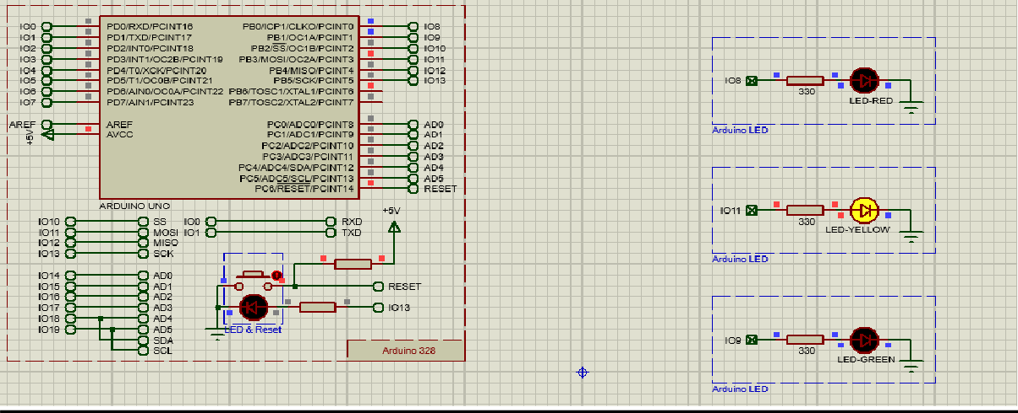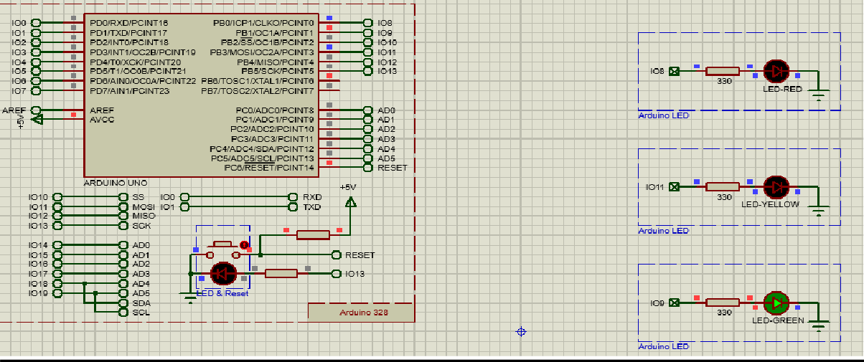

**Flowchart**

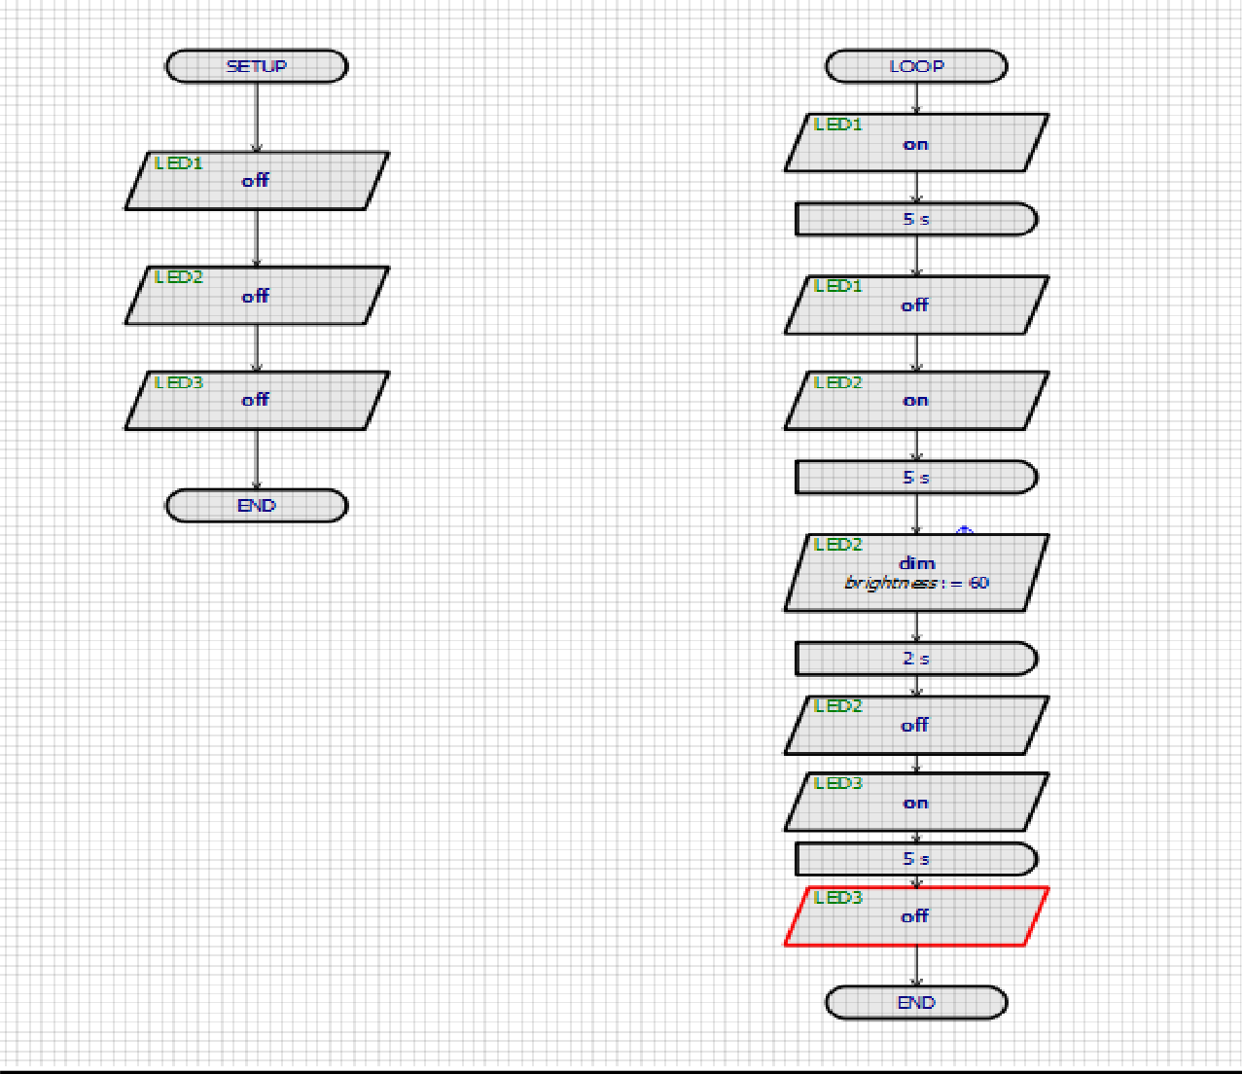

**Discussion:** The purpose of the experiment was to gain experience with the Arduino IDE software and to create an LED blink using the Arduino platform and its delay functions. Additionally, a traffic control system was built using the Arduino microcontroller. To begin, the code was written in the IDE software and tested on a breadboard circuit. Once confirmed, the code was then transferred to the Arduino board. The experiment was successfully completed without any hardware or code-related issues and produced similar results both in simulation and in real-life testing.

**Reference(s):**

1. https://[www.arduino.cc/.](http://www.arduino.cc/)
2. htt[ps://www.course](http://www.coursera.org/learn/arduino/lecture/ei4ni/1-10-first-glance-at-a-program)r[a.org/learn/arduino/lecture/ei4ni/1-10-first-glance-at-a-program](http://www.coursera.org/learn/arduino/lecture/ei4ni/1-10-first-glance-at-a-program)
3. Jeremy Blue; Exploring Arduino: Tools and Techniques for Engineering Wizardry